
Contestant Number:

Time:

Rank:

PC SERVICING AND TROUBLESHOOTING
(305)

STATE – 2020

TOTAL POINTS ___________ (500 points)

Failure to adhere to any of the following rules will result in disqualification:
- Contestant must hand in this test booklet and all printouts. Failure to do so
will result in disqualification.
- No equipment, supplies, or materials other than those specified for this event
are allowed in the testing area. No previous BPA tests and/or sample tests or
facsimile (handwritten, photocopied, or keyed) are allowed in the testing area.
- Electronic devices will be monitored according to ACT standards.

TEST TIME: 60 Minutes

Property of Business Professionals of America.
May be reproduced only for use in the Business Professionals of America
Workplace Skills Assessment Program competition.

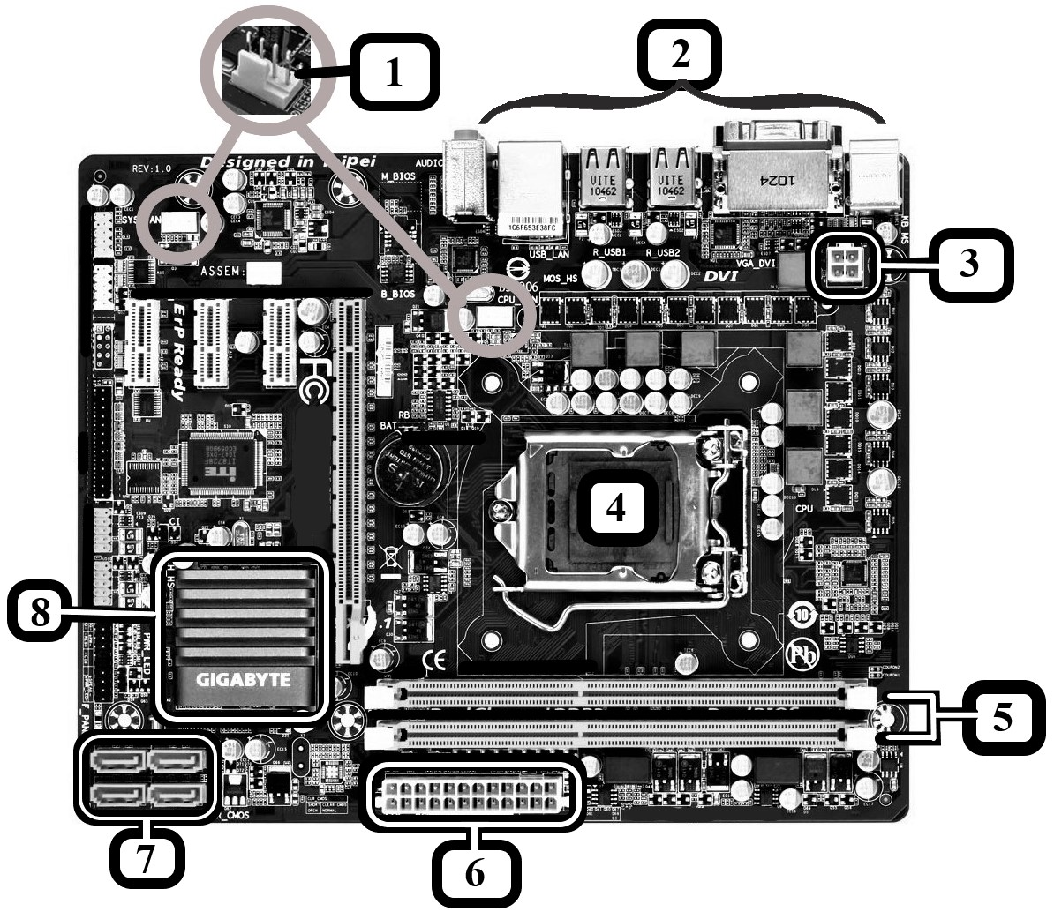
MULTIPLE CHOICE
Identify the letter of the choice that best completes the statement or answers the question. Mark A if the statement is True. Mark B if the statement is False.
Use the diagram above to answer questions 1-10

- Looking only at component 1, what is most likely to be true about this system?
  - it supports fan speed control through pulse width modulation
  - BIOS configuration is controlled by a group of 4 jumpers
  - this system board requires a power supply with a 4-pin Berg connector
  - this system board requires a power supply with a 4-pin Molex connector

- The components marked number 2 are called ____________________ .
  - front panel connectors
  - onboard ports or integrated components
  - capacitors and resistors
  - heat sinks

- What is the purpose of the component marked number 3?
  - supplies an extra 12V power to high-end video cards
  - provides 4 extra pins for a 20+4-pin P1 connector used with a 20-pin board
  - supplies an extra 12V power to the processor
  - supplies power to the CPU fan

- The component marked 4 is an example of a/an _______________.
  - single chipset housing architecture
  - ZIF socket
  - passive cooling system
  - multiprocessor platform

- The components marked number 5 are called ____________________.
  - DIMM slots
  - PCI slots
  - PCIe slots
  - PCI-X slots

- The component marked number 6 is a/an _____________________.
  - IDE host adaptor
  - 20-pin P1 connector
  - 24-pin P1 connector
  - SCSI connector

- What component / device is likely to be connected to a component marked number 7?
  - case USB connector
  - internal IDE hard drive
  - external hard drive
  - internal serial DVD drive

- The component marked number 8 is a/an _____________________.
  - processor under a heatsink
  - chipset under a heatsink
  - CMOS chip
  - auxiliary memory

- How many PCIe expansion slots does this system board have?
  - 1
  - 3
  - 4
  - 6

- This H61 Sandy Bridge Chipset system board is compatible with an AM3+ processor.
  - true
  - false
- What is the maximum amount of memory a 32-bit machine can use?
  - 4GB
  - 16GB
  - 32GB
  - 128GB

- The Windows registry is stored in the ____________________ folder by default.
  - C:\Windows\System32\config
  - C:\Windows\Temp
  - C:\Windows\Registration
  - C:\Program Files\registry

- Which of the following can use quad channels?
  - Only DDR3 DIMMs
  - Only DDR4 DIMMs
  - DDR2 and DDR4 DIMMs
  - DDR3 and DDR4 DIMMs

- All of the following transmit data and power except:
  - eSATAp
  - FireWire
  - eSATA
  - USB

- A power supply with a 115V/220V switch is a/an _______________.
  - transformer
  - inverter
  - rectifier and transformer
  - inverter and transformer

- The printer is printing garbled characters instead of my document. Which of the following actions is the least likely to resolve the problem?
  - update the printer drivers
  - make sure all connections to the printer are secure
  - power cycle the printer
  - replace the toner cartridge

- There is memory in a computer and you are adding extra memory in single channel mode. Which of the following characteristics must match for the system to work/boot?
  - registered/buffered vs. unbuffered
  - frequency
  - storage size
  - brand

- What is the network id of a computer with the following IP address: 192.168.80.23
  - 192.168.80.0
  - 192.168.0.0
  - 192.0.0.0
  - not enough information given

- The computer’s ________________ provides a user interface and manages files, hardware, and applications on the computer.
  - operating system
  - BIOS / UEFI
  - software
  - firmware

- The first 4 blocks of my IP address are FE80:: What do I know about this address?
  - it's a loopback address
  - it’s a public internet address
  - it’s a private network address
  - not enough information given

- You press the power button on the front of the computer but the computer fails to power on. Which of the following should you try first?
  - test the power supply
  - verify the outlet has power / circuit breaker is on
  - verify the switch on the back is in the on position and power cord is plugged in
  - verify the POWER SW connector is correctly connected to the system board

- What type of Windows installation allows you to install a second copy of the Windows OS in its own partition or on a separate drive without changing the existing OS?
  - in-place upgrade
  - multiboot
  - clean install
  - boot partition reformat

- The ____________________ is used to transfer user accounts, files, OS settings and application settings to a new Windows installation.
  - Drive Imaging Utility (DIU)
  - Windows Assessment and Deployment Kit (ADK)
  - Push Automation Feature (PAF)
  - User State Migration Tool (USMT)

- ___________ is a resource that allows a device to request processing time from the CPU.
  - DMA
  - GPT
  - IRQ
  - MBR

- A computer in a small office environment is unable to connect to the internet. You notice its IP address is 169.254.15.7. What should you do first?
  - verify connectivity to the multifunction router and that the router is running
  - verify connectivity to the DNS server and that the DNS server is running
  - check the physical connection between the router and external network
  - install a new network adaptor
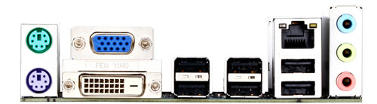
Use the diagram above to answer questions 26 and 27 below.

- Which port are you most likely to use to connect the computer above to a monitor that only provides digital output?
  - RCA audio / video cable
  - VGA
  - DVI-D
  - HDMI

- Which of the following ports could be used to connect the computer above to a printer?
  - RJ45 only
  - Serial only
  - USB only
  - RJ45 or USB

- Which of the following lists the technologies in order of their recommended data transfer range (reliable signal transmission distance or longest cable supported) from shortest to longest distance?
  - Infrared, NFC, Bluetooth, USB
  - NFC, Bluetooth, Infrared, USB 3.0
  - Bluetooth, NFC, Infrared, USB 3.0
  - NFC, USB 3.0, Infrared, Bluetooth

- The hex value E09B is _______________ in binary
  - 57499
  - 1110 1001 1011 0001
  - 1110 0000 1001 1011
  - 1011 1001 0000 1110

- After inserting a new expansion card in a computer, you start Windows but only some features of the card are accessible. What is the next step?
  - return the faulty card to the vendor
  - install the latest compatible drivers from the Windows store
  - install the latest compatible drivers available at the card manufacturer’s website
  - enable all features of the card in the BIOS/UEFI settings

- ________________ is a hidden Windows file that provides virtual memory to the system.
  - swapfile.sys
  - storage.sys
  - vmfile.sys
  - pagefile.sys

- The binary number 111011 is _______________ in hexadecimal.
  - 23
  - 3B
  - 59
  - E3

- _____________ provides a maximum speed of 480 Mbps.
  - USB 2.0
  - USB 3.0
  - USB C
  - SuperSpeed USB

- How many Kb is 1.5 Gb?
  - 1500
  - 15000
  - 1500000
  - 15000000

- The platform controller hub connects to the processor using the ______________.
  - FSB
  - memory bus
  - PCIe link
  - QPI

- The most common file system used by DVDs is __________________ .
  - FAT32
  - UDF
  - NTFS
  - ReFS

- What should you do if S.M.A.R.T. errors display during the boot process?
  - back up data and replace the hard drive as soon as possible
  - run the CHKDSK utility to check the hard drive for bad sectors
  - flash the BIOS to update the firmware
  - use the Windows System Repair Utility to repair the Windows installation

- What is not a critical setting for protecting the system from hackers and malware?
  - intrusion detection is enabled in the BIOS / UEFI security settings
  - antivirus/anti-malware software regularly scans and updates definitions
  - network security setting is set correctly for the optimum firewall setting
  - Windows Update is configured to update automatically

- An inkjet printer might need _____________ if colors are streaked and out of alignment.
  - cleaning
  - conditioning
  - calibration
  - a new ink cartridge

- Which of the following statements is true about solid state drives?
  - lifespan is limited by the number of times data can be rewritten to them
  - they are less expensive than magnetic hard drives with similar capacity
  - they use ROM type of memory
  - they are slower and less reliable than magnetic drives

- A computer beeps 8 times and then shuts down when you try to boot it. This indicates…
  - the computer passed all POST tests
  - a video card problem.
  - a memory problem.
  - the system has overheated.

- Which Windows tool allows you to identify a memory problem?
  - mdsched.exe
  - regsvr.exe
  - mmc.exe
  - serial presence detect (SPD)

- A keylogger that captures and transmits your keystrokes in an attempt to steal personal information is an example of ______________ .
  - grayware
  - spyware
  - a trojan
  - phishing

- Windows logs can be viewed using _________________ .
  - mmc.exe
  - compmgmt.msc
  - logfiles.sys
  - eventvwr.msc
- Which of the following TCP/IP protocols would not be used to configure a connection to an e-mail server?
  - IMAP
  - POP
  - SMB2
  - SMTP

- Which of the following is a valid public IP address?
  - 54.255.46.7
  - 127.0.0.1
  - 169.254.35.19
  - 92.37.256.18

- Which of the following is a valid IP address:
  - FE80::23C8:100B::F9A3:12BF
  - 2001:5G0E:88F2:HE88:8601:GAF9:FB21:1001
  - 2001:0000:0F99:45E7:B600:2AF6:8341:749A:AB00
  - 2001::D307:CE

- Which of the following can be typed into the command line to view the Windows internet address settings on a computer?
  - nbstat -n
  - netstat-b
  - ipconfig /displaydns
  - ipconfig /all

- You are asked to configure a computer with 4—100GB hard drives with at least 350GB of storage space accessible to the user. The daily data backup system currently in place is sufficient for the data that will be on the machine. What’s the optimal set up?
  - create a spanned volume using all 4 disks
  - create a RAID 0 striped volume using all 4 disks
  - create a Raid-5 volume (striped with parity) using all 4 disks
  - create a RAID10 volume (data mirrored across pairs of striped disks)

- You’re assembling a computer from spare parts. The system board has SATA3 connectors. What will be the outcome if you install a SATA2 hard drive?
  - The hard drive will work with a data speed of 3Gb/sec.
  - The hard drive will work with a data speed of 4.5Gb/sec.
  - The hard drive will work with a data speed of 6Gb/sec.
  - The hard drive won’t be recognized because it’s not SATA3.

